Module 14 Challenge

Start Assignment

* **Due** Mar 5 by 23:59

* **Points** 100

* **Submitting** a text entry box or a website url

**Background**

In this assignment, you will build an interactive dashboard to explore the [Belly Button Biodiversity datasetLinks to an external site.](http://robdunnlab.com/projects/belly-button-biodiversity/), which catalogues the microbes that colonise human navels.

The dataset reveals that a small handful of microbial species (also called operational taxonomic units, or OTUs, in the study) were present in more than 70% of people, while the rest were relatively rare.

**Before You Begin**

1. Create a new repository for this project called belly-button-challenge. *Do not add this Challenge to an existing repository*.
2. Clone the new repository to your computer.
3. Inside your local git repository, copy the files from in the StarterCode folder contained within the Module 14 Challenge zip file. i.e. index.html, samples.json, and the static folder.

**NOTE**

You will not be required to access the samples.json file locally, but it is provided for reference.

1. Push the above changes to GitHub.
2. Deploy the new repository to GitHub Pages.

**Files**

Download the following files to help you get started:

[Module 14 Challenge filesLinks to an external site.](https://static.bc-edx.com/data/dla-1-2/m14/lms/starter/Starter_Code.zip)

**Instructions**

Complete the following steps:

1. Use the D3 library to read in samples.json from the URL https://2u-data-curriculum-team.s3.amazonaws.com/dataviz-classroom/v1.1/14-Interactive-Web-Visualizations/02-Homework/samples.json.
2. Create a horizontal bar chart with a dropdown menu to display the top 10 OTUs found in that individual.

* Use sample_values as the values for the bar chart.
* Use otu_ids as the labels for the bar chart.
* Use otu_labels as the hovertext for the chart.

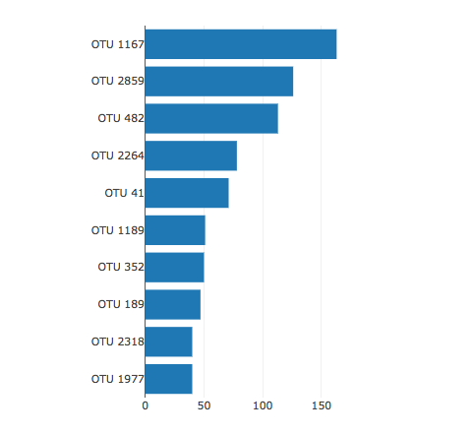

1. Create a bubble chart that displays each sample.

* Use otu_ids for the x values.
* Use sample_values for the y values.
* Use sample_values for the marker size.
* Use otu_ids for the marker colors.
* Use otu_labels for the text values.

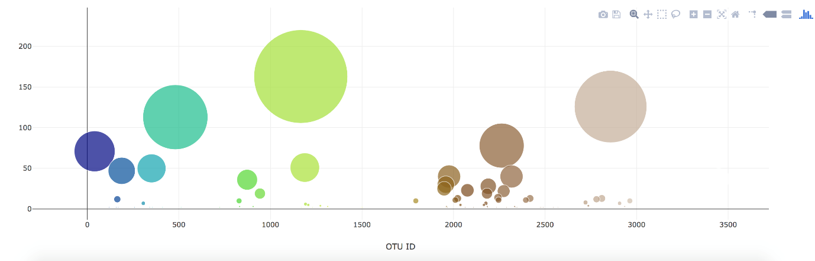

1. Display the sample metadata, i.e., an individual's demographic information.
2. Display each key-value pair from the metadata JSON object somewhere on the page.

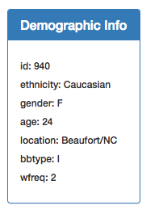

1. Update all the plots when a new sample is selected. Additionally, you are welcome to create any layout that you would like for your dashboard. An example dashboard is shown as follows:

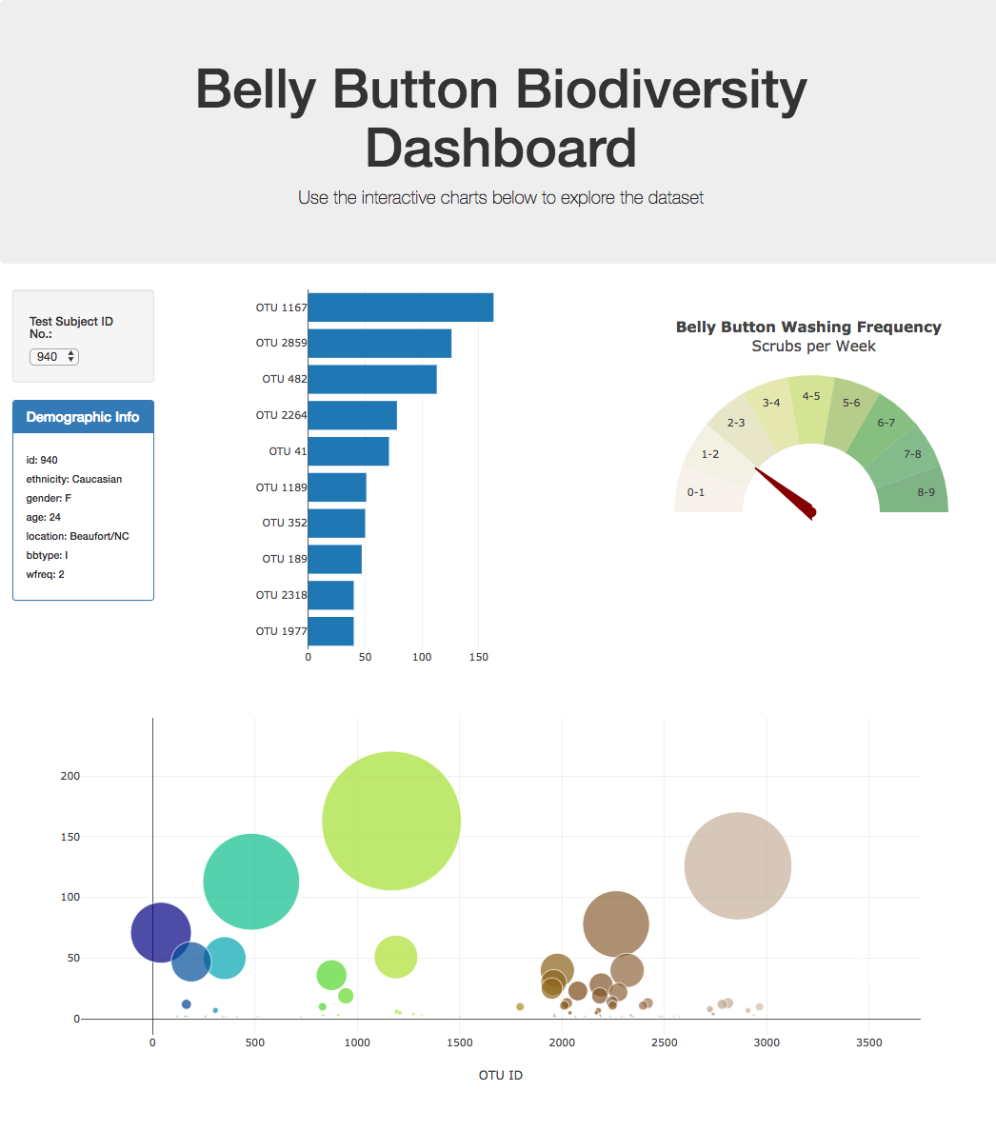

1. Deploy your app to a free static page hosting service, such as GitHub Pages. Submit the links to your deployment and your GitHub repo. Ensure that your repository has regular commits and a thorough README.md file

**Advanced Challenge Assignment (Optional with no extra points earning)**

The following task is advanced and therefore optional.

* Adapt the Gauge Chart from [https://plot.ly/javascript/gauge-charts/Links to an external site.](https://plot.ly/javascript/gauge-charts/) to plot the weekly washing frequency of the individual.
* You will need to modify the example gauge code to account for values ranging from 0 through 9.
* Update the chart whenever a new sample is selected.

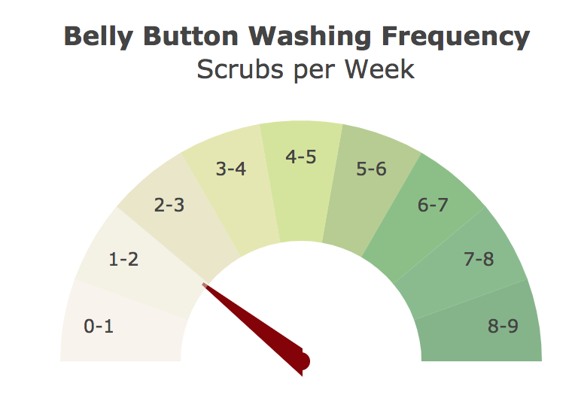

**Hints**

* Use console.log inside of your JavaScript code to see what your data looks like at each step.
* Refer to the [Plotly.js documentationLinks to an external site.](https://plot.ly/javascript/) when building the plots.

**Requirements**

**Bar Chart (30 points)**

* Chart initialises without error (10 points)
* Chart updates when a new sample is selected (5 points)
* Chart uses Top 10 sample values as values (5 points)
* Chart uses otu_ids as the labels (5 points)
* Chart uses otu_labels as the tooltip (5 points)

**Bubble Chart (40 points)**

* Chart initialises without error (10 points)
* Chart updates when a new sample is selected (5 points)
* Chart uses otu_ids for the x values (5 points)
* Chart uses otu_ids for marker colors (5 points)
* Chart uses sample_values for the y values (5 points)
* Chart uses sample_values for the marker size (5 points)
* Chart uses `otu_labels for text values (5 points)

**Metadata and Deployment (30 points)**

* Metadata initialises without error (10 points)
* Metadata updates when a new sample is selected (10 points)
* App Successfully Deployed to Github Pages (10 points)

**Grading**

This assignment will be evaluated against the requirements and assigned a grade according to the following table:

| **Grade** | **Points** |
| --- | --- |
| A (+/-) | 90+ |
| B (+/-) | 80–89 |
| C (+/-) | 70–79 |
| D (+/-) | 60–69 |
| F (+/-) | < 60 |

**Submission**

To submit your Challenge assignment, click Submit, and then provide the URL of your GitHub repository for grading.

**NOTE**

You are allowed to miss up to two Challenge assignments and still earn your certificate. If you complete all Challenge assignments, your lowest two grades will be dropped. If you wish to skip this assignment, click Next, and move on to the next module.

Comments are disabled for graded submissions in Bootcamp Spot. If you have questions about your feedback, please notify your instructional staff or your Student Success Advisor. If you would like to resubmit your work for an additional review, you can use the Resubmit Assignment button to upload new links. You may resubmit up to three times for a total of four submissions.

**IMPORTANT**

**It is your responsibility to include a note in the README section of your repo specifying code source and its location within your repo**. This applies if you have worked with a peer on an assignment, used code in which you did not author or create sourced from a forum such as Stack Overflow, or you received code outside curriculum content from support staff such as an Instructor, TA, Tutor, or Learning Assistant. This will provide visibility to grading staff of your circumstance in order to avoid flagging your work as plagiarized.

If you are struggling with a challenge assignment or any aspect of the academic curriculum, please remember that there are student support services available for you:

1. Ask the class Slack channel/peer support.
2. AskBCS Learning Assistants exists in your class Slack application.
3. Office hours facilitated by your instructional staff before and after each class session.
4. [Tutoring GuidelinesLinks to an external site.](https://docs.google.com/document/d/1hTldEfWhX21B_Vz9ZentkPeziu4pPfnwiZbwQB27E90/edit?usp=sharing) - schedule a tutor session in the Tutor Sessions section of Bootcampspot - Canvas
5. If the above resources are not applicable and you have a need, please reach out to a member of your instructional team, your Student Success Advisor, or submit a support ticket in the Student Support section of your BCS application.

**References**

Hulcr, J. et al. (2012) *A Jungle in There: Bacteria in Belly Buttons are Highly Diverse, but Predictable*. Retrieved from: [http://robdunnlab.com/projects/belly-button-biodiversity/results-and-data/Links to an external site.](http://robdunnlab.com/projects/belly-button-biodiversity/results-and-data/)

[Previous](https://bootcampspot.instructure.com/courses/4525/modules/items/1134402)[Next](https://bootcampspot.instructure.com/courses/4525/modules/items/1134409)

© 2024 edX Boot Camps LLC